✅ 1. INNER JOIN

🎯 Purpose:
Retrieve tickets that have valid users and technicians.
💻 SQL Query (With Comments)
-- INNER JOIN:
-- Retrieves tickets that have matching users and technicians
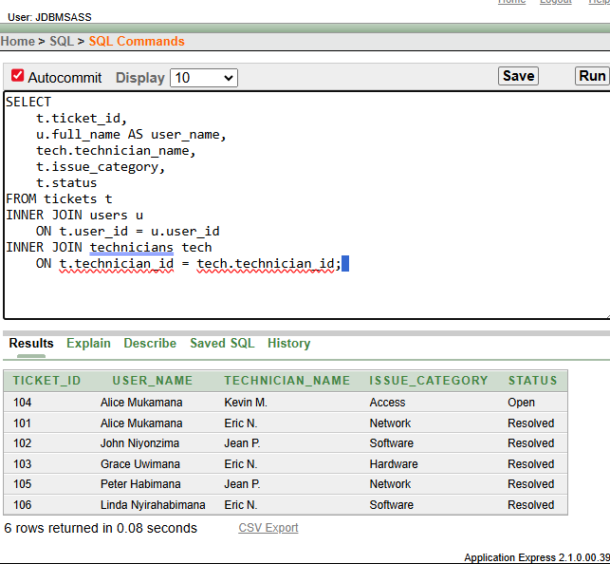

📊 Business Interpretation
This query shows all valid helpdesk tickets where both the user and technician exist in the system. It helps management track which technicians handled which users' issues. This ensures data integrity by showing only properly assigned and recorded support tickets.

✅ 2. LEFT JOIN

🎯 Purpose:
Identify users who have never submitted a ticket.
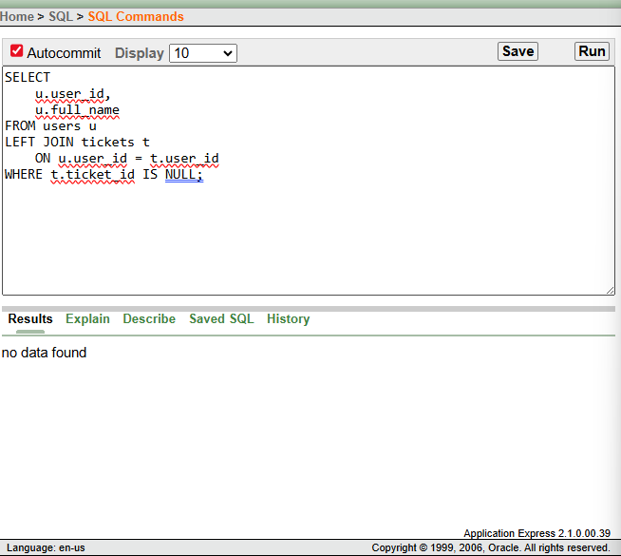

📊 Business Interpretation
This query identifies students or staff who have never contacted the helpdesk. This helps management understand service reach and user engagement levels. The helpdesk may use this information to improve awareness of IT support services.

✅ 3. RIGHT JOIN

🎯 Purpose:
Detect technicians with no assigned tickets.
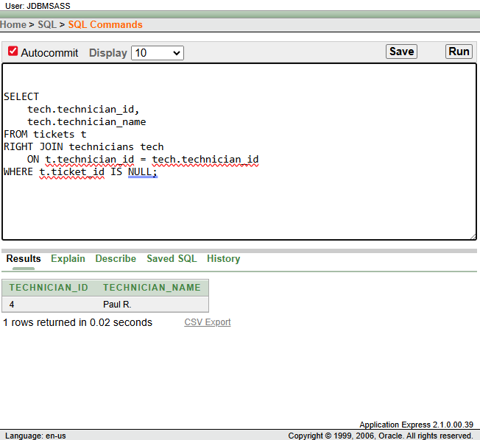

📊 Business Interpretation
This query shows technicians who currently have no assigned support tickets. It helps management evaluate workload distribution across technicians. The results can be used to assign new tickets or balance workload effectively.

✅ 4. FULL OUTER JOIN

🎯 Purpose:
Compare users and tickets including unmatched records.
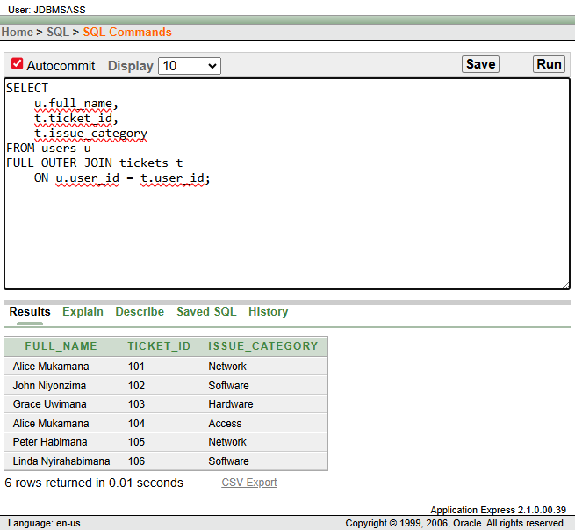

📊 Business Interpretation
This query shows all users alongside ticket records, including users without tickets and tickets without valid users. It helps identify incomplete or missing data and allows management to verify system accuracy. This supports data quality monitoring and auditing.

✅ 5. SELF JOIN

🎯 Purpose:
Compare technicians working in the same region.
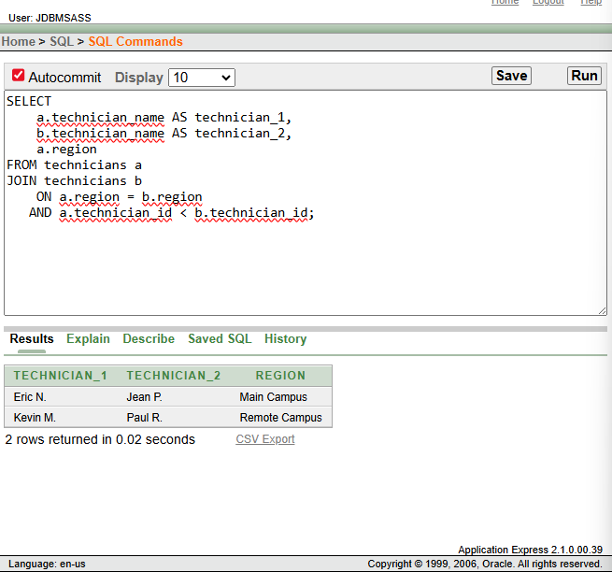

📊 Business Interpretation
This query compares technicians working in the same campus or region. It helps management analyze teamwork opportunities and workload collaboration between technicians. It also assists in planning regional support coverage.
🔹 RANK()
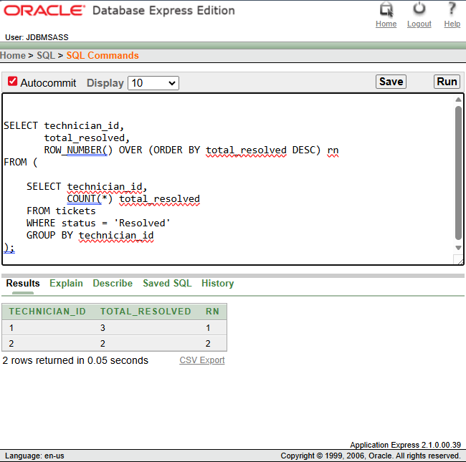

📊 Business Interpretation
This query ranks technicians while allowing tied rankings when performance is equal. Technicians resolving the same number of tickets share the same rank. This provides fair performance comparison.

🔹 DENSE_RANK()

💻 SQL Query

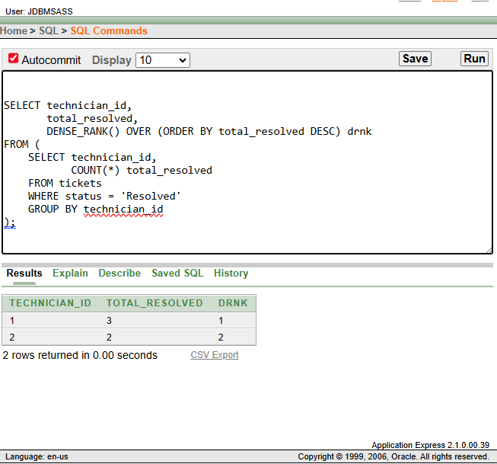

📊 Business Interpretation
This ranking method maintains continuous rank numbering even when ties occur. It creates cleaner performance rankings. Management can use this for structured evaluation reports.

🔹 PERCENT_RANK()

💻 SQL Query

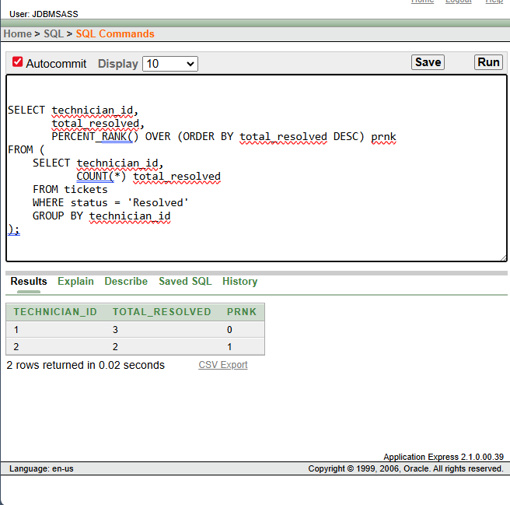

📊 Business Interpretation
This query expresses technician performance relative to others as percentages. It helps management understand overall performance distribution. This supports benchmarking and strategic evaluation.

✅ 2️⃣ AGGREGATE WINDOW FUNCTIONS

🎯 Use Case: Running totals & ticket trends
🔹 Running Total — SUM()
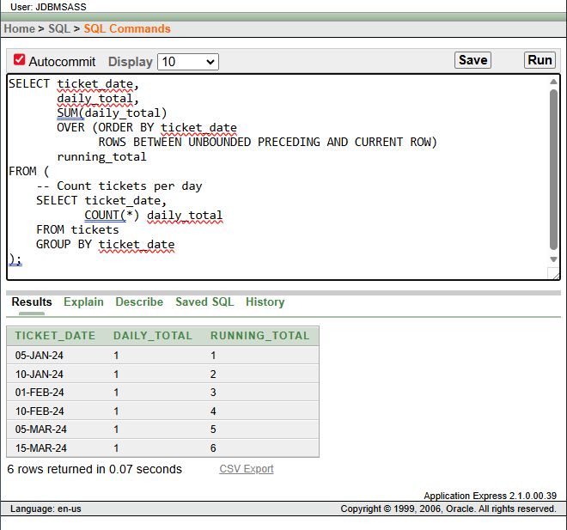

📊 Business Interpretation
This query calculates a cumulative total of helpdesk tickets over time. It helps management observe workload growth patterns. This supports planning and staffing decisions.

🔹 Moving Average — AVG()

💻 SQL Query

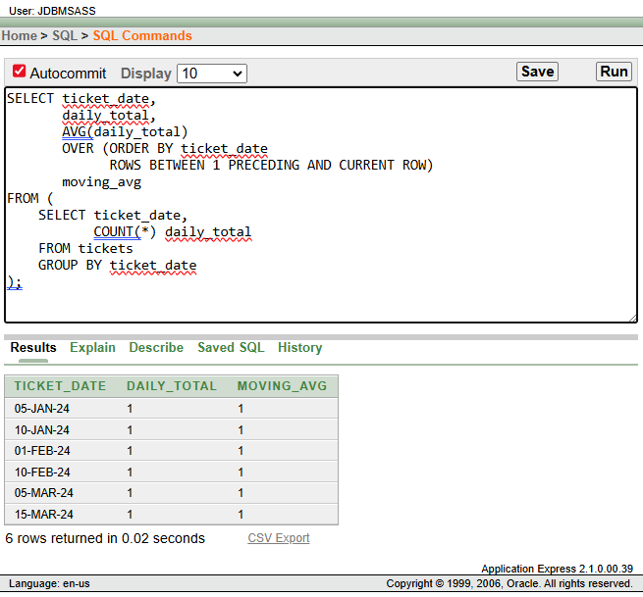

📊 Business Interpretation
This query calculates a moving average of ticket volume. It helps identify trends by smoothing daily fluctuations. Management can use this to anticipate workload changes.

✅ 3️⃣ NAVIGATION FUNCTIONS

🎯 Use Case: Period-to-period ticket comparison

🔹 LAG()

💻 SQL Query

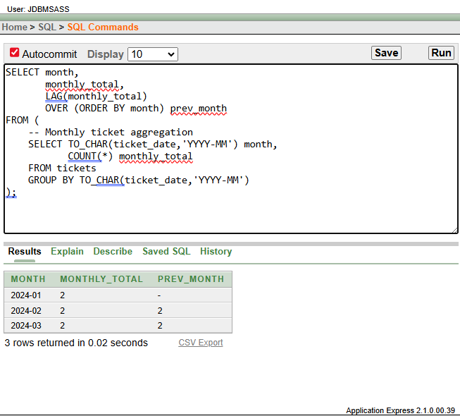

📊 Business Interpretation
This query compares each month’s ticket volume with the previous month. It helps identify increases or decreases in support demand. This supports workload forecasting.

🔹 LEAD()

💻 SQL Query

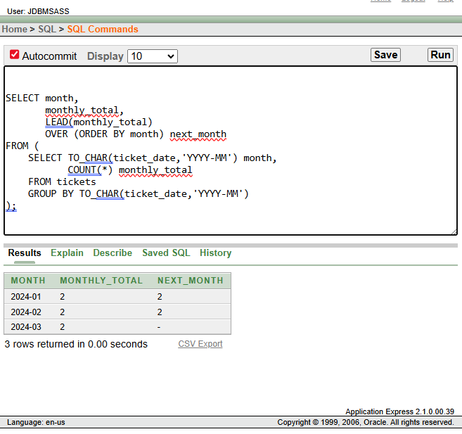

📊 Business Interpretation
This query compares current ticket volume with future periods. It helps management anticipate upcoming workload patterns. This improves proactive planning.

✅ 4️⃣ DISTRIBUTION FUNCTIONS

🎯 Use Case: Technician workload segmentation

🔹 NTILE(4)

💻 SQL Query

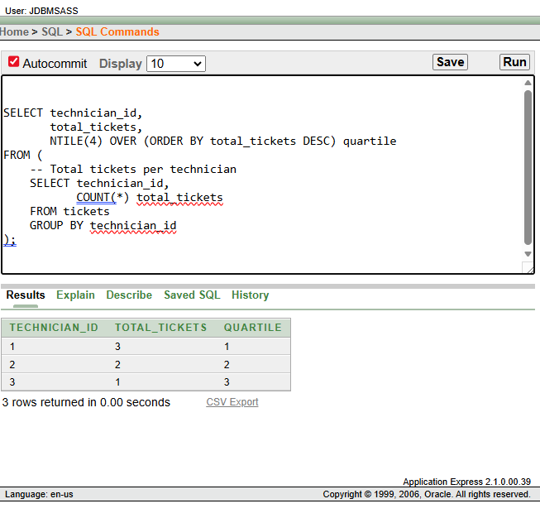

📊 Business Interpretation
This query divides technicians into four workload groups. It highlights high- and low-workload staff. Management can use this for fair task distribution.

🔹 CUME_DIST()

💻 SQL Query

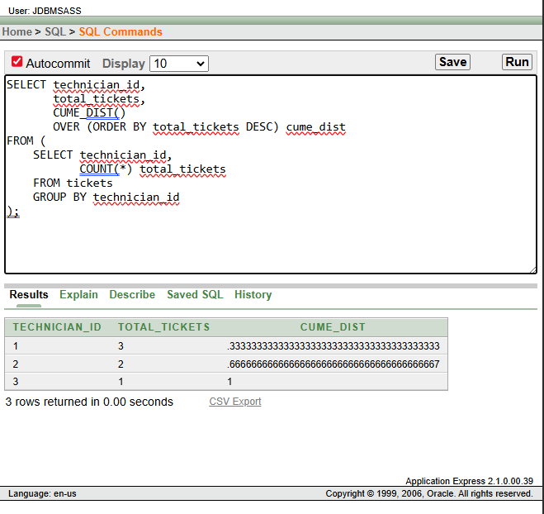

📊 Business Interpretation
This query calculates cumulative technician workload distribution. It shows how performance compares across the team. This helps evaluate workload fairness.

